MEDIA RELEASE
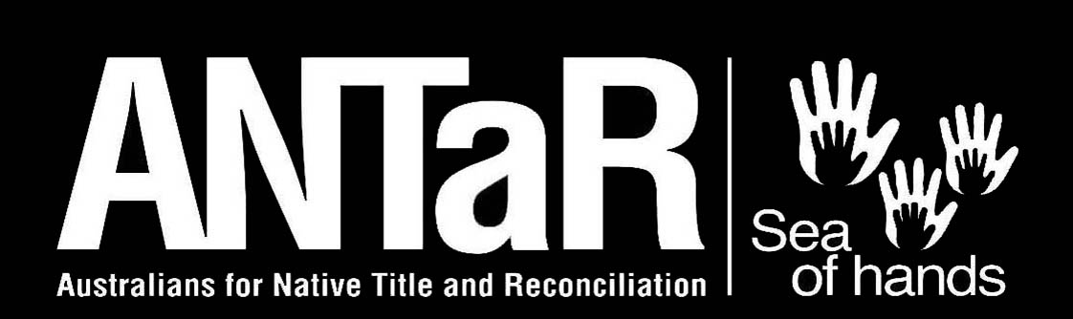

EMBARGOED UNTIL 4.00 AM WEDNESDAY 18 FEBRUARY 2004

Pat Dodson calls for action on Indigenous health crisis

Patrick Dodson, Australia’s ‘Father of Reconciliation’ has called for urgent Government action to stem the crisis in Indigenous health and inequality.

Mr Dodson said governments needed to find the political will to break the cyclical relationship between poor social conditions and the third-world health standards found wherever Aboriginal people are living in cities and remote and regional regions.

Mr Dodson said the crisis stemmed from a potent mix of government neglect, poverty, sub-standard housing, unemployment, and poor education outcomes. This was often fuelled by prejudice, racism and marginalization, which in turn lead to social breakdown, and drug and alcohol dependence.

“These are expressions of underlying trauma and tension that have not been dealt with and remain unresolved.

At the national launch of an Indigenous Health Rights Campaign by Australians for Native Title and Reconciliation (ANTaR), in Sydney today, Mr Dodson called for Australia “to find a way to reach its full potential free of division and inequality. It is only through a commitment to justice that these divisions can be healed.

“Over 40% of all Indigenous Australians are children under fifteen. We must not condemn them to the same appalling life outcomes as their parents, with life expectancies 20 years less than other Australians.

“The current situation is neither intractable nor inevitable – it can be solved. However, if left unaddressed, the inevitable outcomes of increased ill health and spiralling health costs will place unsustainable burdens on Indigenous communities as well as the broader community.

“It is important to understand that this is not simply a medical emergency. It stems from a broader denial of rights. Similar countries such as Canada, New Zealand, and the US have significantly improved the health of their Indigenous peoples over the last 25 years. In these countries treaties with Indigenous peoples and a closer relationship with Federal Governments have delivered better resources and more coordinated action.

“Australia needs similar agreements mechanisms to deal with the current situation. It will require shared commitment between governments and people at all levels. Partnerships with Indigenous people are essential for these to be meaningful. They require adequate resourcing on the basis of need. Health outcomes must be clearly linked to integrated strategies in education, health and housing, as well as the broader recognition of Indigenous peoples in the life of the nation.

“This is a shared responsibility between Indigenous people, governments and the wider Australian public.

“Today we are calling for genuine dialogue leading to a comprehensive agreement on how to resolve these issues.

Mr Dodson is former Chair of the Reconciliation Council and a member of the Indigenous Reference Group that advises ANTaR. Mr Dodson will launch ANTaR’s Healing Hands Indigenous Health Rights Campaign today.

Other speakers: NSW Governor Marie Bashir, ANTaR President Phil Glendenning, AMA President Dr Bill Glasson, Australian Indigenous Doctors Association President Louis Peachey, Ray Martin.

Campaign launch: 10am, Wednesday February 18
Venue: Government House, Macquarie Street, Sydney
Visual: Spectacular Sea of Hands on lawns of Government House
Media contact: Phil Glendenning 0419 013758

